Name _____________________________________________________________________________

Global Studies Final Review – Southeast Asia

Label the map of Southeast Asia

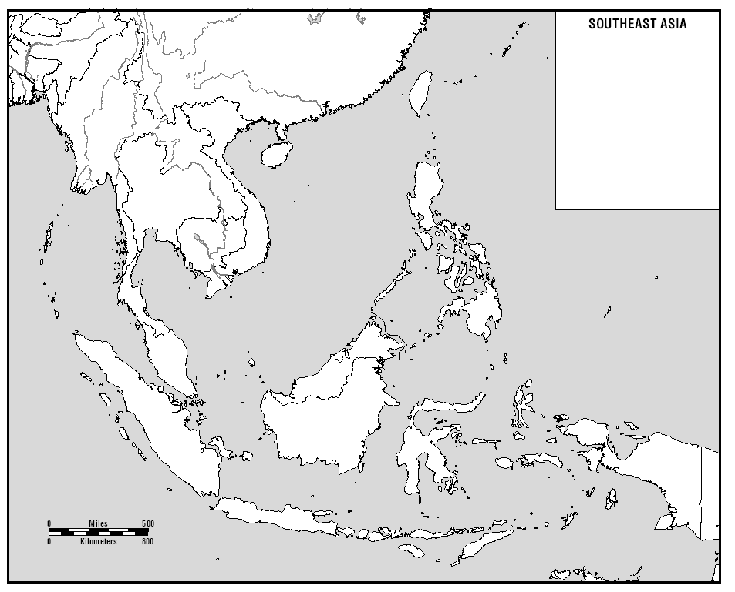
Vietnam, Cambodia, Burma, Philippines, Malaysia, Singapore, Brunei, Laos, Thailand

What are the two main geographic regions of Southeast Asia?

_____________________________________________________________________________________

_____________________________________________________________________________________

_____________________________________________________________________________________

Which nation was ruled by the Khmer Rougue?

_____________________________________________________________________________________

_____________________________________________________________________________________

_____________________________________________________________________________________

What is the impact of monsoons in Southeast Asia?

_____________________________________________________________________________________

_____________________________________________________________________________________

_____________________________________________________________________________________

Why were the Dutch interested in Southeast Asia in the 17th and 18th centuries?

_____________________________________________________________________________________

_____________________________________________________________________________________

_____________________________________________________________________________________

Why did Japan invade Southeast Asia during World War II?

_____________________________________________________________________________________

_____________________________________________________________________________________

_____________________________________________________________________________________

Why did the United States become involved in Southeast Asia in the 1960s and 1970s?

_____________________________________________________________________________________

_____________________________________________________________________________________

_____________________________________________________________________________________

